**Using deep copy**

pointerDataClass.h

#ifndef POINTER_DATA_CLASS_H

#define POINTER_DATA_CLASS_H

#include<iostream>

using namespace std;

class pointerDataClass

{

int maxSize;//variable to store the maximum size of p

int length;//variable to store the number of elements in p

int* p;// pointer to an int array

public:

//Constructor to create an array of the size specified by the parameter size.

pointerDataClass(int size);

//Destructor to deallocate the memory space occupied by the array p

~pointerDataClass();

//the function insertAt inserts num into array p at the position specified by

//index

void insertAt(int index, int num);

//The function displayData displays all the array elements in p

void displayData();

pointerDataClass(pointerDataClass& pdc);

};

#endif

pointerDataClass.cpp

#include "pointerDataClass.h"

// using deep copy

pointerDataClass::pointerDataClass(int size) {

maxSize = size;

length = 0;

p = new int[maxSize];

for (int i = 0; i < maxSize; i++) {

*(p + i) = NULL;

}

}

//Destructor to deallocate the memory space occupied by the array p

pointerDataClass::~pointerDataClass() {

delete[] p;

}

//the function insertAt inserts num into array p at the position specified by

//index

void pointerDataClass::insertAt(int index, int num) {

*(p + index) = num;

length++;

}

//The function displayData displays all the array elements in p

void pointerDataClass::displayData() {

for (int i = 0; i < maxSize; i++) {

if (*(p + i) == NULL) {

cout << "Null" << " ";

}

else {

cout << *(p + i) << " ";

}

}

cout << endl;

}

pointerDataClass::pointerDataClass(pointerDataClass& pdc) {

maxSize = pdc.maxSize;

length = pdc.length;

p = new int[maxSize];

for (int i = 0; i < pdc.maxSize; i++) {

*(p + i) = *(pdc.p + i);

}

}

main.cpp

#include <iostream>

#include "pointerDataClass.h"

//Use deep copy

int main()

{

pointerDataClass list1(10);

list1.insertAt(0, 50);

list1.insertAt(4, 30);

list1.insertAt(8, 60);

cout << "List1: " << endl;

list1.displayData();

cout << "List 2: " << endl;

pointerDataClass list2(list1);

list2.displayData();

list1.insertAt(4, 100);

cout << "List1: (after insert 100 at indext 4) " << endl;

list1.displayData();

cout << "List 2: " << endl;

list2.displayData();

return 0;

}

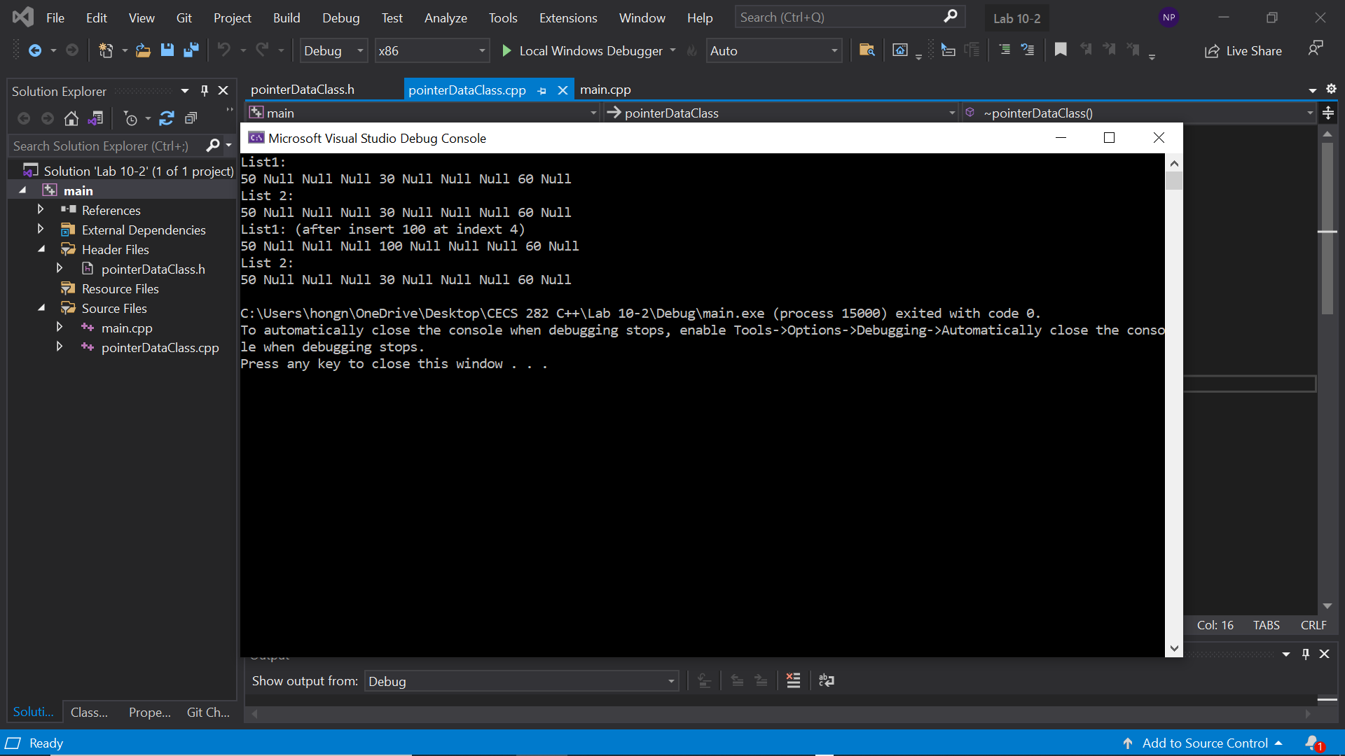

Demonstrated at 11:04 am on 10/21/2021.